27.

A student is experimenting with pulses along a stretched elastic string. The string is tied to a fixed point P. There is a mark on the string at R. The student can send pulses along the string by moving end O up and down.

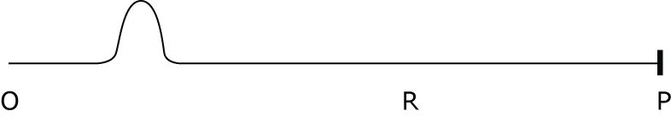

He observes a pulse travelling along the string, and times how long it takes to get to R. He now wants to make a pulse travel to R in a shorter time – by changing just one thing in the set-up. He considers each of the following possible changes:

Change 1: Increasing the tension in the string (making it tighter)
Change 2: Moving his hand up and down further, making a bigger pulse.
Change 3: Moving his hand up and down faster, making a sharper pulse.

Which of these changes, on its own, would make a pulse travel to R in a shorter time?

A 1 only
B 2 only
C 2 or 3 only
D 1, 2 or 3

